### Introduction to Devops ###

1. Any application/ feature released faster to the market will have business advantage
2. People/Teams responsible for doing this should be paid decently.
3. DevOps is all about deploying your application quickly/faster to the market.
4. Let’s understand how the applications are deployed

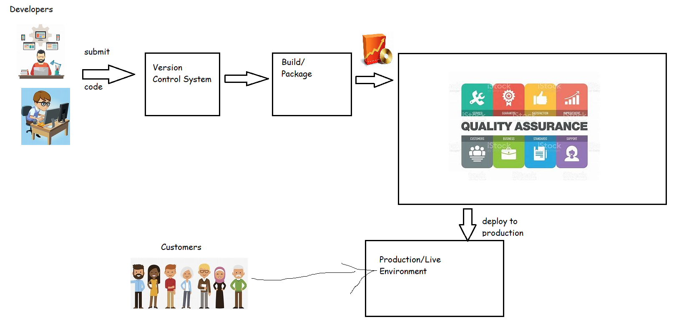

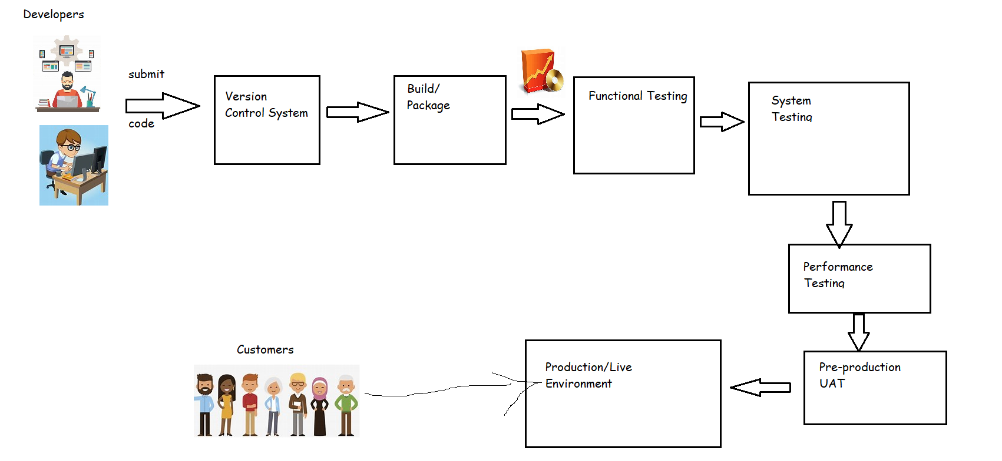

1. As a DevOps Engineer, we need to automate the above workflow which is referred as pipeline.
   1. Pipeline is sequence of steps which we need to perform to deploy your application/give feedback about the quality of the code submitted to your developer& others
   2. Types of pipelines in DevOps

1) Continuous Integration.

2) Continuous Delivery

3) Continuous Deployment

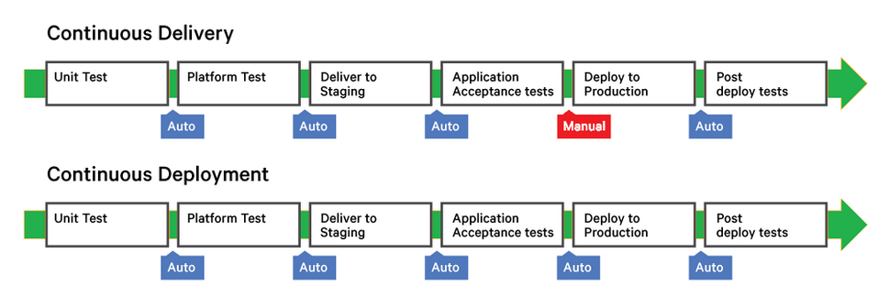

1. DevOps Pipelines with tools

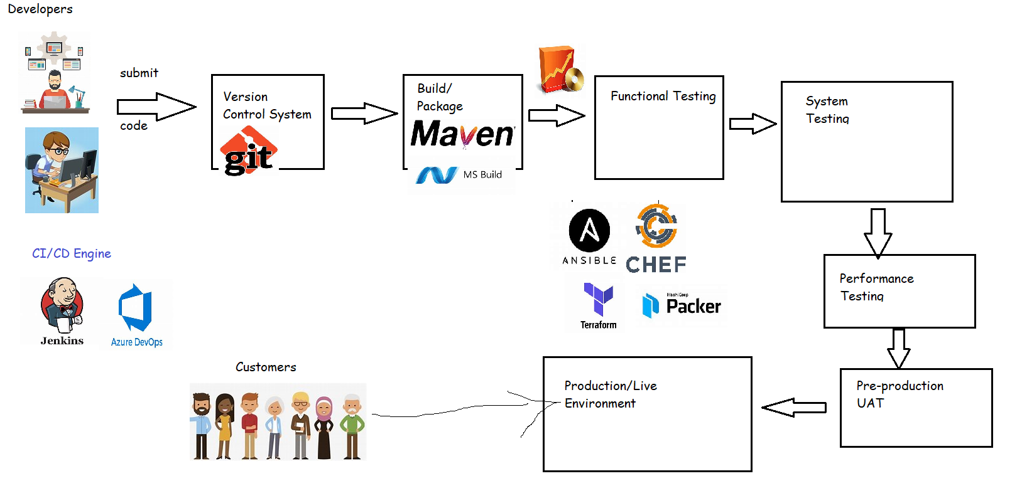

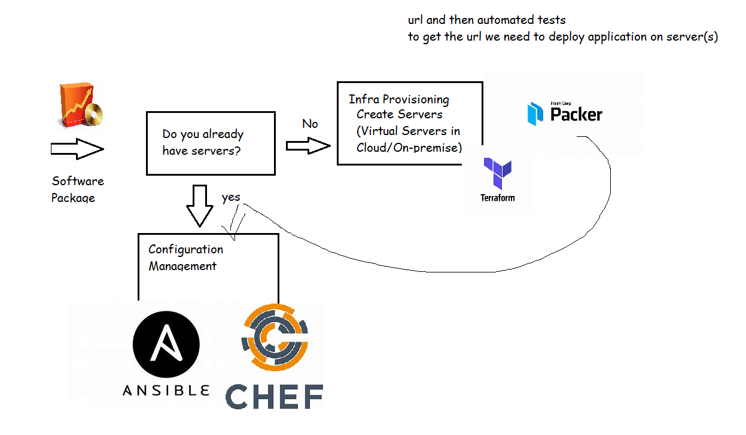

Devops with Monitoring tools

